PROJECT 6
MICROSOFT OFFICE TROUBLESHOOTING
Practical Testing and Troubleshooting Documentation
Portfolio Learner | Samah Iris Afua Harriet
Project | 6 of 8 – Microsoft Office Troubleshooting
Environment | Windows 11 Pro Education | Microsoft Office Professional 2021 (64-bit)

1. Project Overview
The purpose of this project was to verify that Microsoft Office applications were installed and functioning, carry out basic application tests, and practise identifying common Office support issues. The work focused on Word, Excel and PowerPoint.

2. System and Software Identified
The Office Account page identified Microsoft Office Professional 2021 for this device. The About Word information showed Microsoft Word 2021, 64-bit, Version 2607 (Build 20228.20110), Click-to-Run.
The product information page displayed the Office applications included in the installation, including Word, Excel and PowerPoint. The screenshots supplied during the exercise provide visual evidence of the installed Office suite and application windows.

3. Practical Tests Performed
Application / Check | Work completed
Microsoft Word | Opened Word, accessed its Account/Product Information page and checked the About Word details. A document-creation and save test had also been completed.
Microsoft Excel | Opened Excel, entered a small sample table containing Pens (5) and Books (3), and checked the total of 8. The workbook opened and displayed the entered data.
Microsoft PowerPoint | Opened PowerPoint, created a presentation titled “PowerPoint Troubleshooting Test” with the subtitle “Testing presentation functionality”, and saved the presentation.
Existing files | Opening existing Word, Excel and PowerPoint files had already been tested and completed.
Application stability | The user confirmed that Word, Excel and PowerPoint did not freeze during the tests.

4. Troubleshooting Activity: Office Licensing Script
A Command Prompt check was attempted using the Office licensing script path C:\Program Files\Microsoft Office\Office16\OSPP.VBS. Windows Script Host returned an error stating that it could not find the script file at that location.
Finding: this result shows that the script was not present at the specific path used in the command. It does not, by itself, prove that Office is unlicensed or damaged. The Office installation was visible in Word's Account page, but an activation status was not established from the screenshots.
Action taken: no licensing files were changed and no repair or reinstallation was attempted. This was appropriate because the Office applications were opening and functioning during the practical tests. If an activation problem occurs in future, the next checks would be to review the Product Information / activation message in an Office application and confirm the correct account or licence with the authorised administrator or provider.

5. Common Office Issues and Recommended First-Line Checks
- Word or another Office app will not open: Restart the computer, try opening the application in Safe Mode, and check for available Office updates.
- Excel is slow or unresponsive: Close unnecessary workbooks and applications; investigate add-ins if the problem continues.
- PowerPoint content displays incorrectly: Check slide layout, presentation compatibility and display settings.
- Office applications repeatedly crash: Save work where possible, restart the device, and consider an Office repair through Windows Settings or Control Panel.
- Office activation or sign-in issue: Review the activation message, verify the signed-in account and licence, and check internet connectivity.

6. Results and Conclusion
The Office suite was installed and the tested applications opened successfully. Basic document, spreadsheet and presentation tasks were completed, and the user confirmed that the applications did not freeze. No application fault requiring repair was observed during this exercise. The licensing-script command returned a file-path error, which was documented without making unnecessary system changes.
Project outcome: the practical functionality checks were completed. This project strengthened skills in identifying Office versions, checking application information, testing core functions, recognising a command-line path error and choosing safe first-line troubleshooting steps.

7. Screenshot Evidence
The following screenshots were captured during the practical exercise. They are included as supporting evidence of the application checks and test activities.
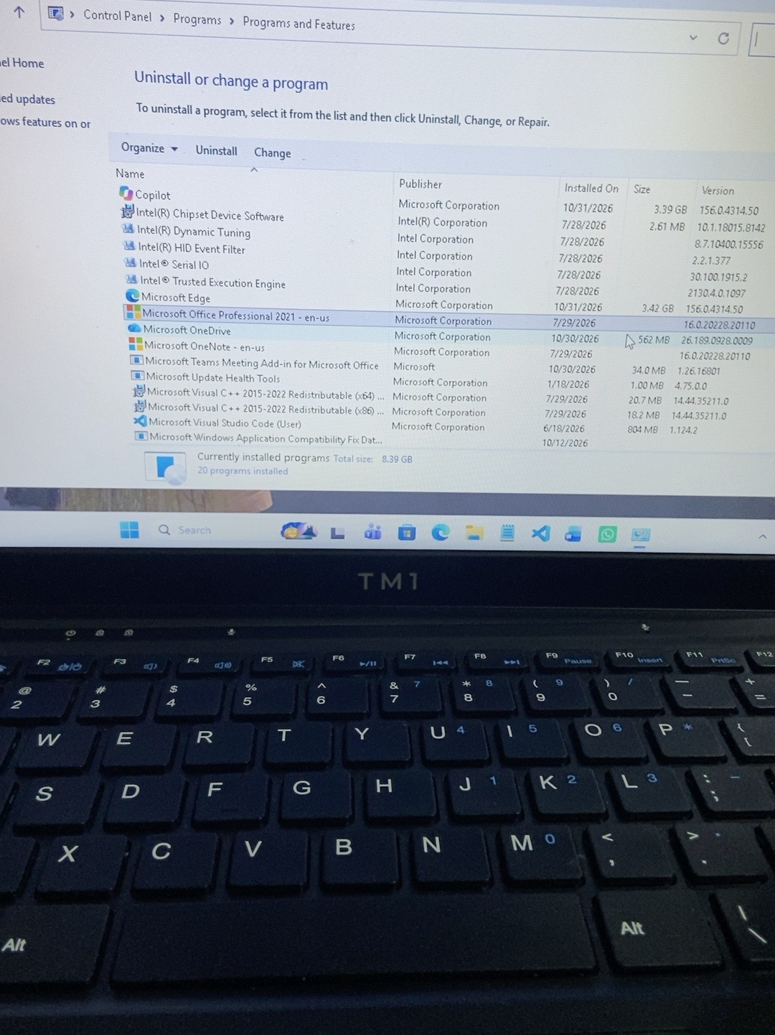
Figure 1. Microsoft Word Account page showing Microsoft Office Professional 2021 for the device.
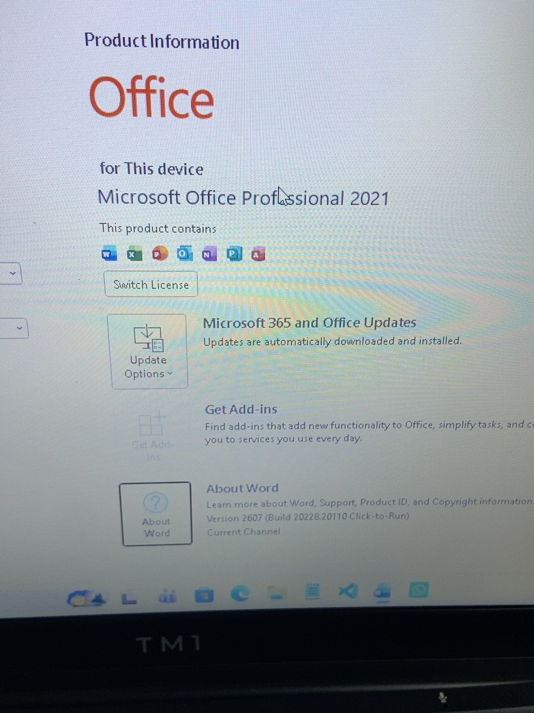
Figure 2. Office Product Information showing the installed Office applications.
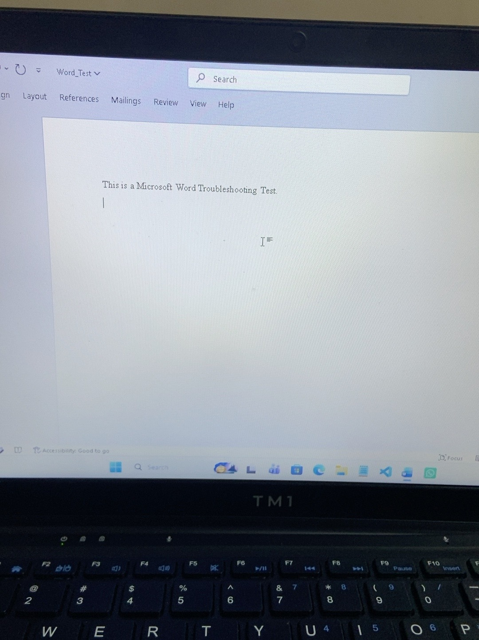
Figure 3. Excel sample worksheet with item quantities and a total of 8.
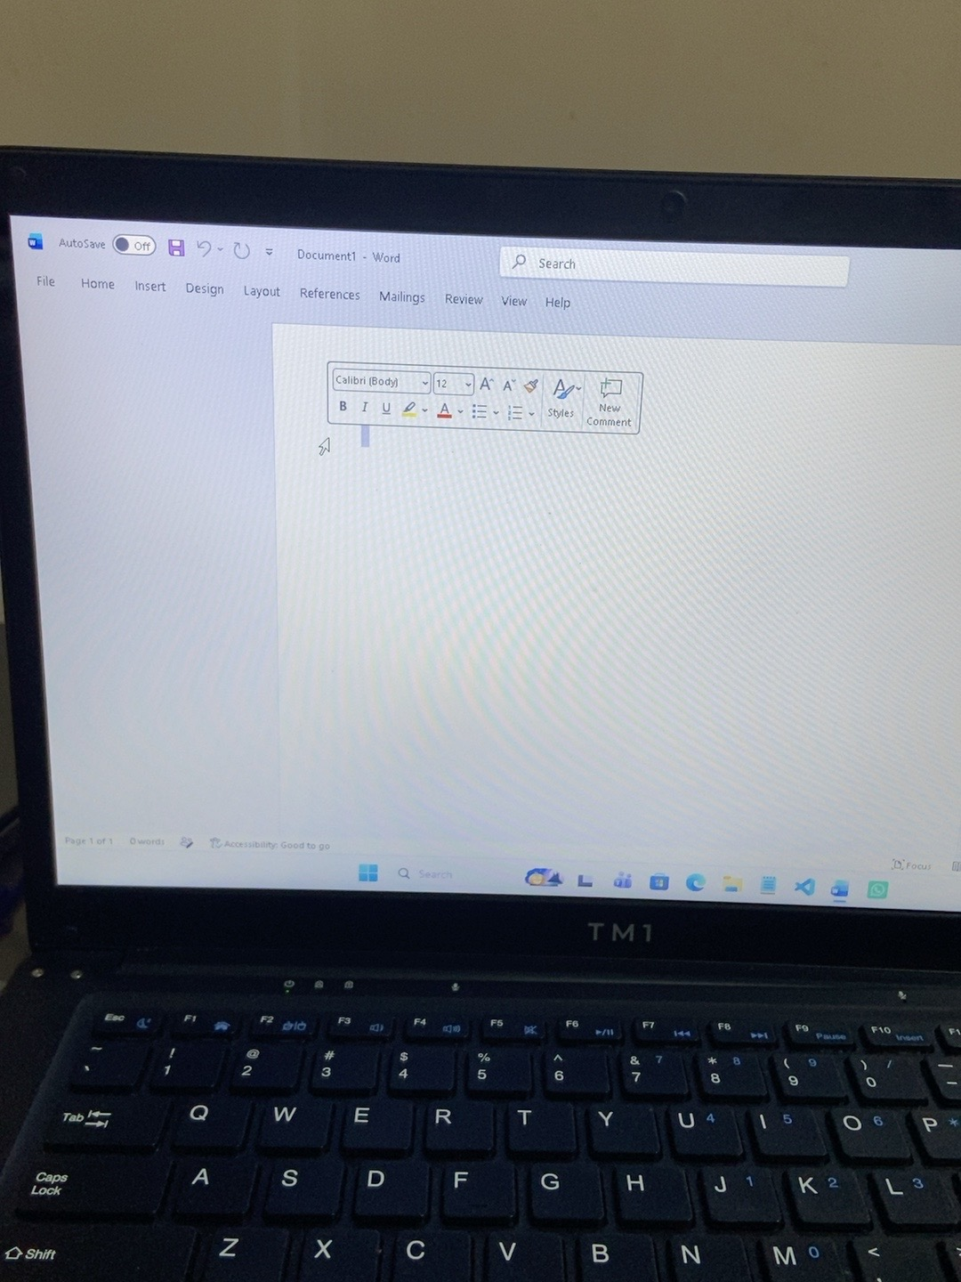
Figure 4. PowerPoint test presentation saved on the device.
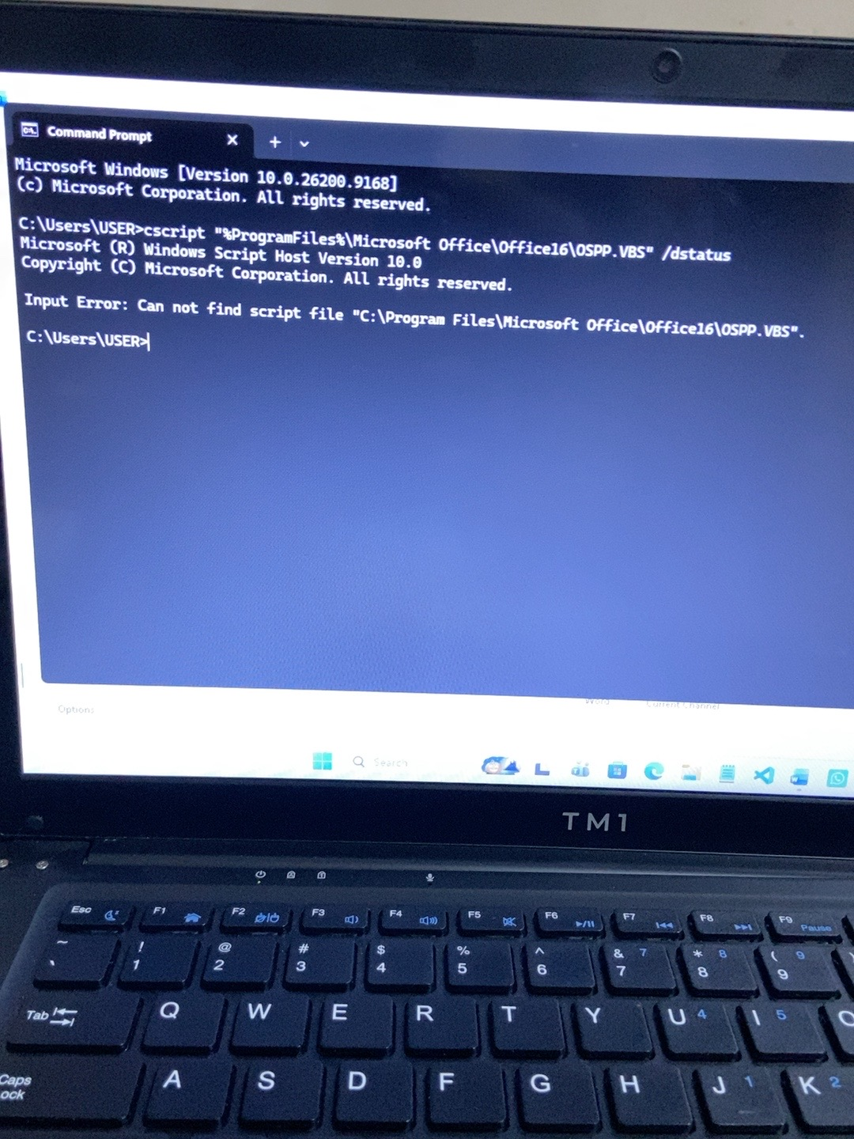
Figure 5. Command Prompt output showing that the specified OSPP.VBS script path could not be found.
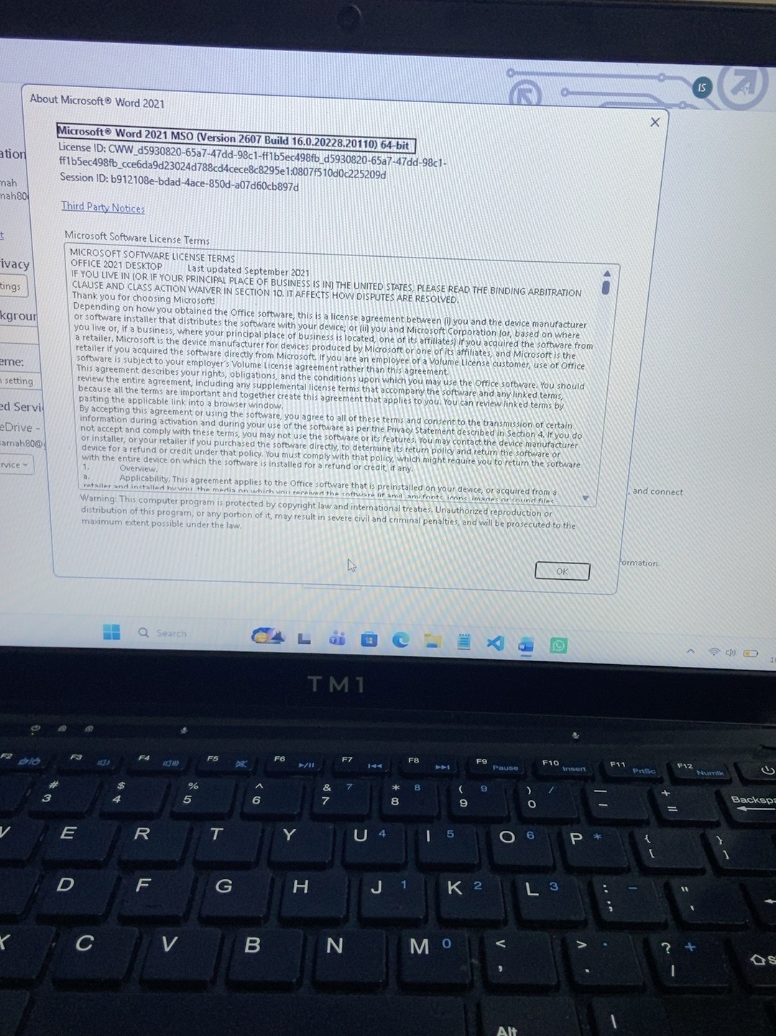
Figure 6. Microsoft Word 2021 About dialog showing the version and 64-bit information.

8. Skills Demonstrated
- Identifying an installed Microsoft Office edition and version.
- Checking Office account and product information.
- Testing basic Word, Excel and PowerPoint functionality.
- Recognising and documenting a command-line file-path error.
- Applying safe troubleshooting judgement and avoiding unnecessary repairs.
- Recording technical findings clearly for a help desk support portfolio.

END OF PROJECT 6 DOCUMENTATION

